|  |  |
| --- | --- |
| **Name:** | DIPTI SHARNAGAT |
| **Roll No & Branch:** | 55 |
| **Class/Sem:** | BE/VII |
| **Experiment No.:** | 03 |
| **Title:** | To develop a scene in Unity that includes: i. a cube, plane and sphere, apply transformations on the 3 game objects.  ii. add a video and audio source. |
| **Date of Performance:** |  |
| **Date of Submission:** |  |
| **Marks:** |  |
| **Sign of Faculty:** |  |

**Aim :-**

To develop a scene in Unity that includes:

1. a cube, plane and sphere, apply transformations on the 3 game objects.
2. ii. add a video and audio source.

**Theory:-**

In Unity, you can create a dynamic scene by adding various game objects and components. In this context, we aim to create a scene that involves a cube, plane, and sphere, and apply transformations to these objects. Transformations, including translation, rotation, and scaling, alter the position, orientation, and size of game objects, respectively. This manipulation of transformations is fundamental for positioning and animating objects within the Unity environment. Additionally, we will add a video and audio source to enhance the scene's interactivity. A video source allows for the playback of video content within the scene, enriching the visual experience. Meanwhile, an audio source provides the capability to integrate sound and music, further engaging users in the immersive environment

**Procedure:-**

1. **Create Project**: Start a new 3D Unity project and ensure you have the required Unity version and video/audio packages installed.
2. **Create & Position Objects**: In the Hierarchy, create game objects (Cube, Plane, Sphere) and adjust their properties.
3. **Import Assets**: Import video (MP4 or WebM) and audio files into the project's "Assets" folder.
4. **Create Materials**: Generate materials for game objects by right-clicking in the Project window, then assign these materials in the Inspector.
5. **Add Video & Audio Components**: For video, create a Video Player component and assign the video clip. For audio, add an Audio Source component and assign the audio clip.
6. **Configure Playback**: Write scripts if needed to control video and audio playback.
7. **Testing**: Save the scene and press Play to verify video/audio playback, object transformations, and material settings.

Top of Form

**Result:-**

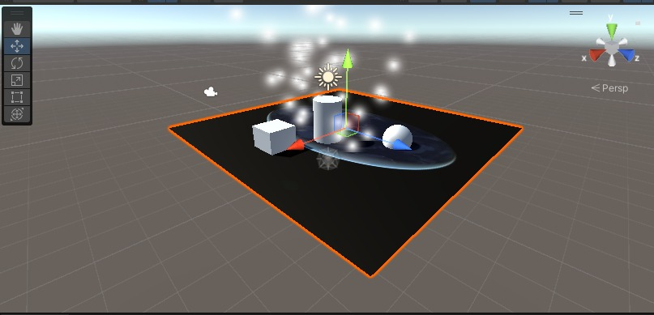

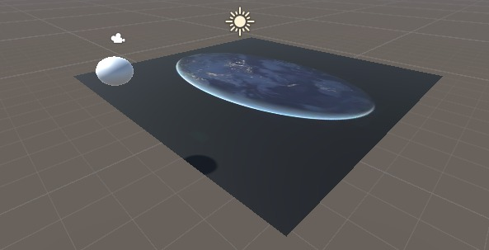

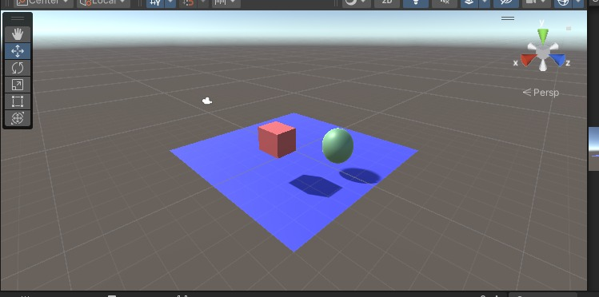

**Conclusion:-**

Developing a scene in Unity with a cube, plane, and sphere while applying transformations showcases fundamental 3D object manipulation. Adding a video and audio source enriches the scene's multimedia elements, enabling a wide range of interactive and immersive experiences. Unity's versatility makes it a powerful tool for creating dynamic and multimedia-rich environments for various applications, from games to simulations and beyond.